**User Story Name: Create Lobby**

* Description: **As a** User **I would like** to view the available lobbies for multiplayer **so that** I can create a room and play against other users.

Acceptance Criteria

* Room is successfully created
* Firebase has a record of the room
* Room is displayed in lobby list

**Use Case**

Name: Create Lobby

Actor: User

Preconditions:

* Actor is registered as a SkillCourt’s player and
* Actor has SkilCourt app installed in his device

Description <Flow of events>:

|  |  |
| --- | --- |
| Actor Steps | System Steps |
| 1.Actor clicks on the Multiplayer menu option |  |
| 2. Actor clicks on ‘Enter Lobby Button’ |  |
| 3.Actor selects the ‘Create Room’ option |  |
|  | 4. System changes activities to request more information |
| 5. Actor enters room name |  |
| 6. Actor is subscribed to room |  |
| 7. Actor is taken to the room |  |

**Unit Test**

* Test case ID:
* Description/Summary of Test: Test if the creation of a room is being reflected in the lobby and Firebase.
* Pre-condition: SkillCourt app running.
* Expected Results: Attempts to create room, subscribe to room and see player information.
* Actual Result: Creates room, subscribes to room and sees player information.
* Status (Fail/Pass): Pass.

**Integration Test**

**Visual User Guide**:

* User opens main menu and chooses Multiplayer

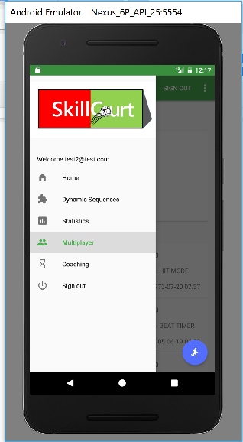

* User selects ‘Enter Lobby’

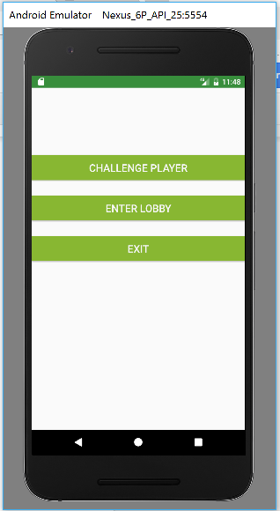

* User selects ‘Create Room’

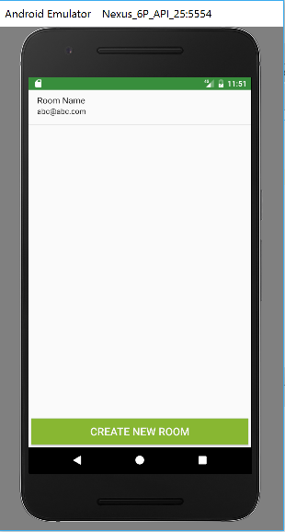

* User confirms their choices

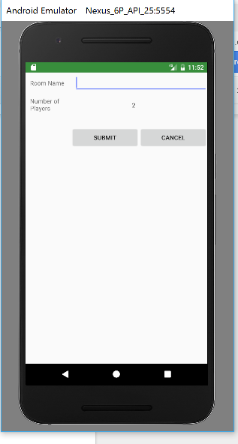

* User is taken to the lobby room

